1 – 3 – Composition of functions – Teaching Set
1. Let $a\left(x\right)=3x+7$ and $b\left(x\right)=2\sqrt{x-3}$.
a. What’s $[a o b](4)$? What’s $[b o a](4)$ ?
b. Find $a\left(b\left(x\right)\right)$ and $b\left(a\left(x\right)\right)$; fully simplify each.
c. If $a\left(b\left(k\right)\right)=25$ what’s k?

2. If $f\left(x\right)=x^{2}+2x+4$ and $g\left(x\right)=\frac{1}{x}$, find the equation for $f\left(g\left(x\right)\right).$ Find the equation for $g\left(f\left(x\right)\right)$.
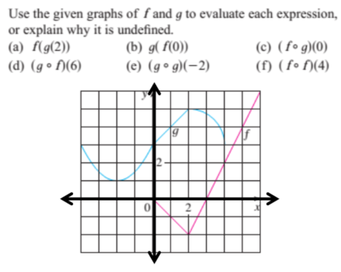
2. a. What’s $f\left(g\left(2\right)\right)$
b. What’s $[g o g](-2)$ ?
c. What’s $[f o g](0)$ ?
d. What’s $\left[g o f\right]\left(0\right)$ ?

3. Let $p\left(x\right)={\left(x-6\right)}^{3}$ . What is p(p(p(p(p(p(p(p(p(p(8))))))))))? [no calculator required!]

4.
What this problem is about:
In problem 2, I said $f\left(x\right)=x^{2}+2x+4$ and $g\left(x\right)=\frac{1}{x}$ , so $f\left(g\left(x\right)\right)={\left(\frac{1}{x}\right)}^{2}+2\left(\frac{1}{x}\right)+4$
In this problem I want you to think about this in reverse. If I show you ${\left(\frac{1}{x}\right)}^{2}+2\left(\frac{1}{x}\right)+4$ I want you to “see” that $\frac{1}{x}$ is the “inside” function and $x^{2}+2x+4$ is the “outside” function. So instead of plugging an equation into another one, you’ll separate one equation into two separate ones.
For each function h, find functions f and g so that $h\left(x\right)=f\left(g\left(x\right)\right)$
a). $h\left(x\right)={\left(x+1\right)}^{2}-3\left(x+1\right)+4$
b). $h\left(x\right)=2^{\sqrt{4-x}}$ has two slightly different solutions
c). $h\left(x\right)=\sqrt[3]{x^{4}+1}$ has two slightly different solutions.

5. These problems all fit together to show you something.
a). Let $f\left(x\right)=x^{2}$ and $g\left(x\right)=\sqrt{x}$ . Does $\left[f o g\right]\left(x\right)=\left[g o f\right]\left(x\right)$ ?

b). Ok, to check your idea, compute $g\left(f\left(-2\right)\right)$. What did you get? This should convince you that $\left[g o f\right]\left(x\right)≠x$. If it’s not x, what function is is equal to?

c). A second issue: compute $f\left(g\left(-2\right)\right)$. What did you get? This should convince you that $f\left(g\left(x\right)\right)≠g\left(f\left(x\right)\right)$ for all values of x. For what x-values are they not equal?

d). The lesson of (c) is that algebraic equivalence isn’t the same as function equality because for functions you have to think about the domain of input values for which the function is valid.

Since $g\left(x\right)=\sqrt{x}$ is a real-valued function, its domain is $x≥0$.
That means $f\left(g\left(x\right)\right)=x$ and $g\left(f\left(x\right)\right)=x$ only for $x≥0$, since that’s the only domain on which $g(x)$ is defined.

Pause and make sure that statement makes sense to your whole group.

This idea will come back again at a few points during the year and is the source of some traps in thinking. For now a good take away is remembering that there is a difference between simplifying algebra and then treating it as if it’s an equivalent function.

1 – 3 – Composition of functions – Solutions
1. Let $a\left(x\right)=3x+7$ and $b\left(x\right)=2\sqrt{x-3}$.
a. What’s $[a o b](4)$? What’s $[b o a](4)$ ?

$[a o b](4)$ means “a of (b of 4)” and can be written this way: $a\left(b\left(4\right)\right)$.
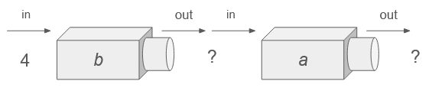
The input to a is the output from b(4).
So $b\left(4\right)=2\sqrt{4-3}=2$. Plug that into a to get $a\left(2\right)=13$

$[b o a](4)$ is the reverse order: “b of (a of 4)” and can be written this way: $b\left(a\left(4\right)\right)$.
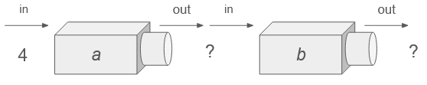
The input to b is the output from a(4).
So $a\left(4\right)=3\left(4\right)+7=19$.
Plug that into b to get $b\left(19\right)=2⋅\sqrt{19-3}=2⋅4=8$

b. Find $a\left(b\left(x\right)\right)$ and $b\left(a\left(x\right)\right)$; fully simplify each.
$a\left(b\left(x\right)\right)$: $b(x)$ is $2\sqrt{x-3}$, so we’ll substitute that as the input to a. $a\left(2\sqrt{x-3}\right)=3\left(2\sqrt{x-3}\right)+7=6\sqrt{x-3}+7$
$b\left(a\left(x\right)\right)$: $a(x)$ is $3x+7$ so let’s plug that in as an input to $b(x)$. $b\left(3x+7\right)=2\sqrt{\left(3x+7\right)-3}=2\sqrt{3x-4}$

c. If $a\left(b\left(k\right)\right)=25$ what’s k?
Here’s one (but not the only) way you could solve for k. First, let’s find what $a\left(b\left(k\right)\right)$ actually is as an equation. $b\left(k\right)=2\sqrt{k-3}$ (we just plugged in k for x). So send that as input to a to get $a\left(b\left(k\right)\right)=6\sqrt{k-3}+7$. Now set that equal to 25 and solve for k.

$6\sqrt{k-3}+7=25$ $6\sqrt{k-3}=18$ $\sqrt{k-3}=3$ $k-3=9$ $k=12$

2. If $f\left(x\right)=x^{2}+2x+4$ and $g\left(x\right)=\frac{1}{x}$, find the equation for $f\left(g\left(x\right)\right).$ Find the equation for $g\left(f\left(x\right)\right)$.
Plugging in $\frac{1}{x}$ to f we get: $f\left(g\left(x\right)\right)=f\left(\frac{1}{x}\right)=$ ${\left(\frac{1}{x}\right)}^{2}+2\left(\frac{1}{x}\right)+4$
Plugging in $x^{2}+2x+4$ to g we get: $g\left(f\left(x\right)\right)=g\left(x^{2}+2x+4\right)=$ $\frac{1}{x^{2}+2x+4}$

2. The idea here is to think about taking the output from one function and using it as input to the other. The only difference is you have to read the outputs from a graph rather than calculating them from an equation.
a. What’s $f\left(g\left(2\right)\right)$? $g(2)$ is 5. Then $f(5)$ is 4
b. What’s $[g o g](-2)$? $g(-2)$ is 1. Then $g(1)$ is 4
c. What’s $[f o g](0)$ ? $f\left(g\left(0\right)\right)=f\left(3\right)=0$
d. What’s $\left[g o f\right]\left(0\right)$ ? $g\left(f\left(0\right)\right)=g\left(0\right)=3$

3. Let $p\left(x\right)={\left(x-6\right)}^{3}$ . What is p(p(p(p(p(p(p(p(p(p(8))))))))))? [no calculator required!]
This looks extremely tedious! Sometimes it’s worth just taking the first step to see what there is to see though.
The first step is finding $p(8)$ which is $p\left(8\right)={\left(8-6\right)}^{3}=2^{3}=8$. Ah, ha! If $p\left(8\right)=8$ then $p\left(p\left(8\right)\right)=p\left(8\right)=8$.
And $p\left(p\left(p\left(8\right)\right)\right)=p\left(p\left(8\right)\right)=p\left(8\right)=8$. In other words, you can compose p with itself as many times as you want and if the input is 8, you’ll keep getting the output of 8. This is called a fixed point for this function. You can think more about fixed points in some of the challenge problems.
4.
What this problem is about:
In problem 2, I said $f\left(x\right)=x^{2}+2x+4$ and $g\left(x\right)=\frac{1}{x}$ , so $f\left(g\left(x\right)\right)={\left(\frac{1}{x}\right)}^{2}+2\left(\frac{1}{x}\right)+4$
In this problem I want you to think about this in reverse. If I show you ${\left(\frac{1}{x}\right)}^{2}+2\left(\frac{1}{x}\right)+4$ I want you to “see” that $\frac{1}{x}$ is the “inside” function and $x^{2}+2x+4$ is the “outside” function. So instead of plugging an equation into another one, you’ll separate one equation into two separate ones.
For each function h, find functions f and g so that $h\left(x\right)=f\left(g\left(x\right)\right)$
a). $h\left(x\right)={\left(x+1\right)}^{2}-3\left(x+1\right)+4$
I notice $x+1$ happening in two places. If I imagine them as blobs I see: $h\left(x\right)={\left(x+1\right)}^{2}-3\left(x+1\right)+4$
If I plug in $x+1$ for the blog, I’d get the original function. That suggests that the inner function is $x+1$ and the outer function is $x^{2}-3x+4$. So: $f\left(x\right)=x^{2}-3x+4$ and $g\left(x\right)=x+1$. Then $f\left(g\left(x\right)\right)=h(x)$
b). $h\left(x\right)=2^{\sqrt{4-x}}$ has two slightly different solutions
Of course, there’s always the trivial solution where $f\left(x\right)=2^{\sqrt{4-x}}$ and $g\left(x\right)=x$. Then, of course, $h\left(x\right)=f\left(g\left(x\right)\right)$. That’s all very silly, though, so let’s not do it.
One way to see the outer function is: $2^{stuff}$. Then the inner function is: $\sqrt{4-x}$
Another way is to see it is: $2^{\sqrt{stuff}}$. Then the inner function is $4-x$
So, one solution is: $f\left(x\right)=2^{x}$ and $g\left(x\right)=\sqrt{4-x}$
The other is: $f\left(x\right)=2^{\sqrt{4-x}}$ and $g\left(x\right)=4-x$
c). $h\left(x\right)=\sqrt[3]{x^{4}+1}$ has two slightly different solutions.
You could see this as: $\sqrt[3]{x^{4}+1}$ or as $\sqrt[3]{x^{4}+1}$.
That gives one solution as: $f\left(x\right)=\sqrt[3]{x}$ and $g\left(x\right)=x^{4}+1$
Another solution is: $g\left(x\right)=\sqrt[3]{x+1}$ and $g\left(x\right)=x^{4}$

5. These problems all fit together to show you something.
a). Let $f\left(x\right)=x^{2}$ and $g\left(x\right)=\sqrt{x}$ . Does $\left[f o g\right]\left(x\right)=\left[g o f\right]\left(x\right)$ ?
Ok, let’s use algebra.
$[fog](x)$ is $f\left(g\left(x\right)\right)={\left(\sqrt{x} \right)}^{2}=x$
$\left[gof\right]\left(x\right)$ is $g\left(f\left(x\right)\right)=\sqrt{x^{2}}=x$

Looks very convincing. Seems like the answer is probably yes?

b). Ok, to check your idea, compute $g\left(f\left(-2\right)\right)$. What did you get? This should convince you that $\left[g o f\right]\left(x\right)≠x$. If it’s not x, what function is is equal to?

Uh oh. $f\left(-2\right)={\left(-2\right)}^{2}=4$. Then $g\left(4\right)=\sqrt{4}=2$. Here $x$ was -2, but we got 2 as an ouput.
Let’s think more naturally about what’s happening here. If you send any negative number through $x^{2}$ it will become positive. Then, taking the square root undoes the squaring, but the result is still positive.
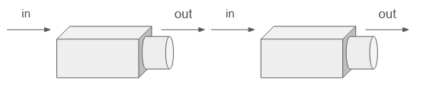

positive #
(negative #)²
$$\sqrt{x}$$
$$x^{2}$$
negative #

Imagine a table of values here.
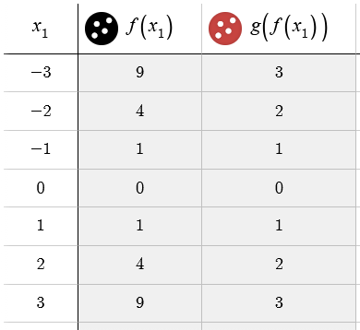
$$\sqrt{x^{2}}$$
$$x^{2}$$
$$x$$
Earlier we’d written that $\sqrt{x^{2}}$ is x. But clearly that’s not true.

What’s a function you do know which has this pattern of inputs and outputs?

Pause and think about it yourself. The final answer is in part d on the next page.

c). A second issue: compute $f\left(g\left(-2\right)\right)$. What did you get? This should convince you that $f\left(g\left(x\right)\right)≠g\left(f\left(x\right)\right)$ for all values of x. For what x-values are they not equal?
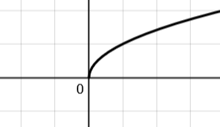
$g\left(-2\right)=\sqrt{-2}$ which is undefined if we we’re treating $g(x)$ as a real-valued function. Imagine the graph of $y=\sqrt{x}$. $x=-2$ is outside the domain of the function. (You may have been introduced to the idea that $\sqrt{-2}$ is a valid number (called a complex number). For now, let’s assume $g(x)$ only outputs real values. In that case, $g(-2)$ is undefined.)

In that case $f\left(g\left(-2\right)\right)=f\left(undefined\right)=undefined$.

d). The lesson of (c) is that algebraic equivalence isn’t the same as function equality.
What does that mean? When simplifying algebra, you’re used to re-writing ${\left(\sqrt{x}\right)}^{2}$as $x$. That’s not wrong, but when simplifying algebra you’re really asking: “do these expressions give the same outputs whenever they’re both allowed to be used?”

If you’re asking whether $f\left(x\right)={\left(\sqrt{x}\right)}^{2}$ equals $g\left(x\right)=x$, then you also have to compare the domains for which they’re defined. $f(x)$ is only defined on $x≥0$ whereas $g(x)$ is defined for all real inputs. So: $f\left(x\right)=g(x)$ on the domain $x≥0$ only.

$\sqrt{x^{2}}$ equals x only on the domain $x≥0$. When $x<0$, $\sqrt{x^{2}}$ equals $-x$.
So, you could write this piecewise: $g\left(f\left(x\right)\right)=\left\{\begin{matrix}x & if x≥0 \\ -x & if x<0\end{matrix}\right.$ . You could also realize we have a special symbol for this function: $g\left(f\left(x\right)\right)=|x|$.

In other words: $\sqrt{x^{2}}=|x|$ for all real numbers.

This idea will come back again at a few points during the year and is the source of some traps in thinking. For now a good take away is remembering that there is a difference between simplifying algebra and then treating it as if it’s an equivalent function.

